MGP Group 17
Note Matching Algorithms

There are many ways in which the notes can be placed in the game field, the best method in terms of playability is the procedural method.

One procedural method is to spawn a note every time the volume in a song spikes, a high volume spike would probably be a drum being hit for example. This is easily done by analysing the waveform and then whenever the waveform spikes place the note. However, this method will probably not work with the type of music we are looking at, and will probably be better for rock music.

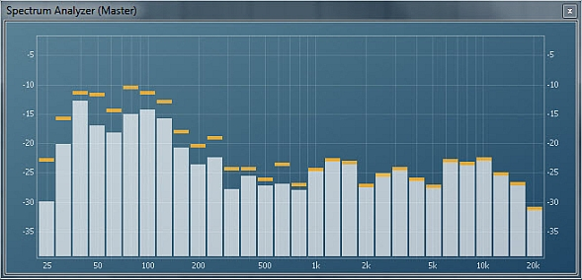

We could also detect changes in volume separately in different frequency spectrums, this way you can spawn a note for different levels of pitch. Different instruments operate at different frequencies. We could have each “track” represent a different frequency.

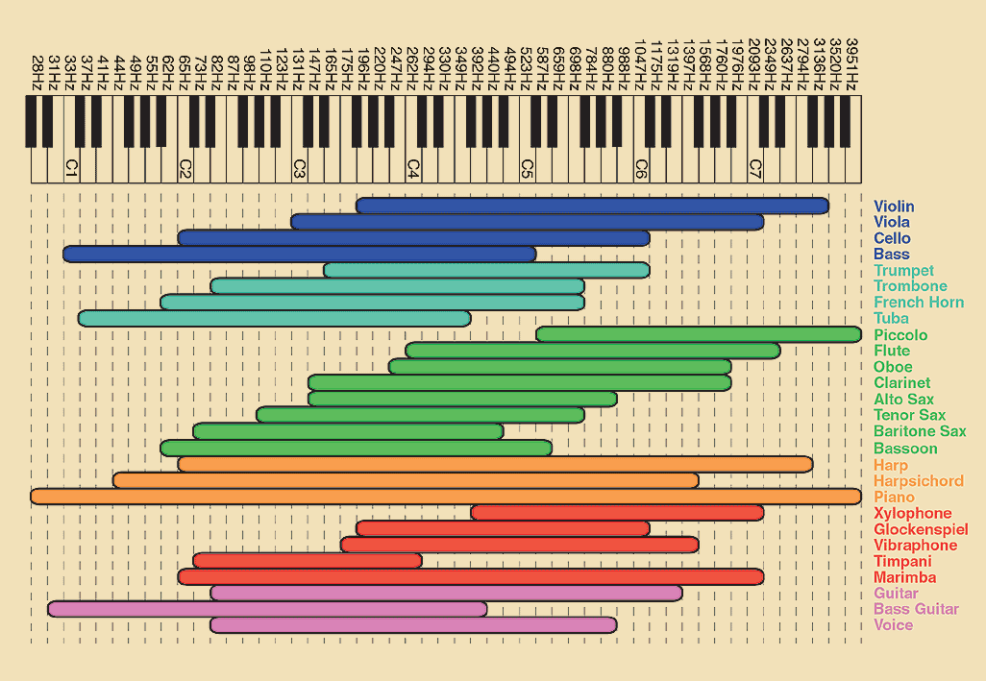

For each of the procedural approaches, its necessary to interpolate each fame, as its difficult to get precise audio playback in unity and on most devices there would be some audio lag. There also may be video lag, the way to fix this is to get the user to tap along to a video clip before they play and then determine how much lag there is, however this would probably put off a lot of players. Because this is a rhythm game however, the visual latency isn’t that important as you would want to play the note when you hear it not when you see it.

A user on reddit at https://www.reddit.com/r/gamedev/comments/13y26t/how_do_rhythm_games_stay_in_sync_with_the_music/ explains this issue in more detail.

There are also tracks created for rhythm games, where MP3 files come with a text file that describes the notes in the songs. This however would limit our music choices severely and there is a limited selection of tracks that fit our theme. This would also require coding to read from a file the notes and generate the track, which could result in a long loading time for the players.

Another option is using MIDI tracks. These are files which represent the instruments in a song and provide directly the notes for each instrument. This would be easy to then determine where the notes should be placed. There however are a limited number of MIDI songs, most of which probably are not suitable for our chosen genre of music. It would also be difficult to match these MIDI tracks with the actual song, as MIDI tracks don’t contain any vocals and are usually not made by the original artist, we couldn’t really use the MIDI tracks directly as that wouldn’t be auditory simulating for the player.
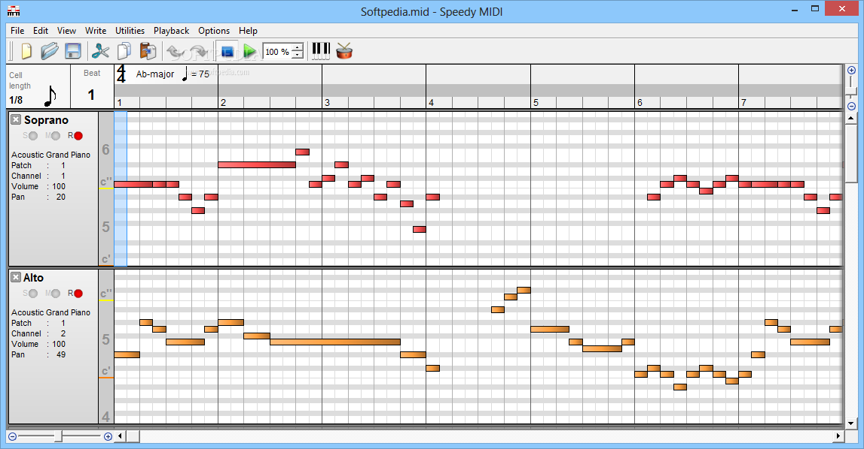

Another approach we could take is the manual approach, this however would be time consuming and limit the number of songs we use.

The manual approach idea is to have a limited number of songs that we select and include with the game. In development we play the song, and then tap the screen or press a mouse button and record the notes in time with the music. This is very time consuming however and depending on the track could be quite difficult. This method would suit best for slow music or simple tracks.

